TI 23 – 04 Technology Example – Hydrovolve Hammer

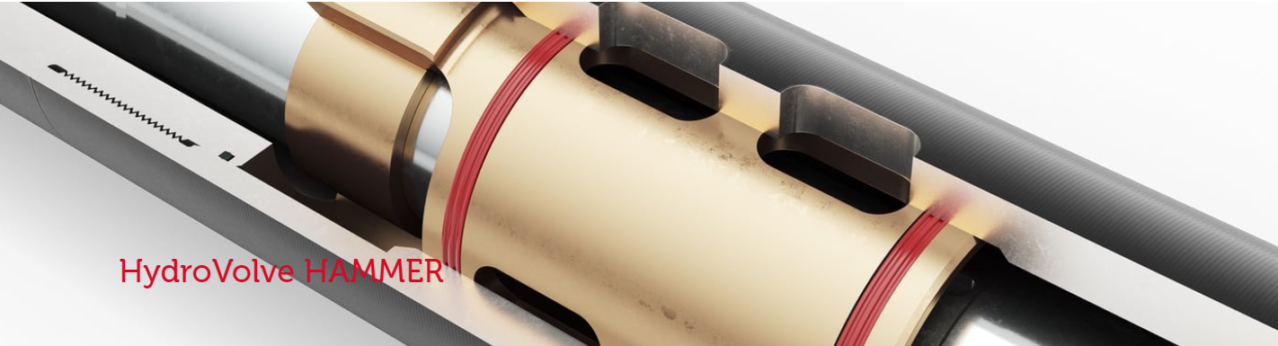

HydroVolve HAMMER is the world’s most powerful, most controllable and most versatile stuck-object extraction system. It is simple, rapid and robust and is operated and controlled instantly using only conventional rig systems.
It is the superior alternative to jars in the BHA for preventing and remedying stuck-pipe incidents, and is the ideal solution for fishing interventions and planned P&A operations.
HydroVolve HAMMER is powered by the HydroVolve INFINITY engine to generate and deliver intense vibration and rapid impact force to liberate stuck objects. It utilises the PolyVolve swivel to allow immense overpulls to be applied to stuck objects at the same time as delivering intense, high energy vibro-impact extraction forces. This combination is designed to deliver swift stuck object extraction thereby minimising downtime and increasing operational success.
Link to Vendors website for further information:
HydroVolve Hammer

